**7.1 G-levels Graphs**

**G-levels for time 0-40 seconds**

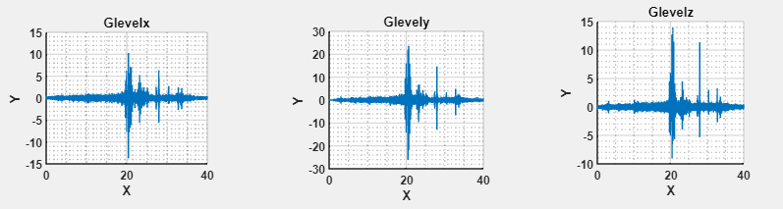

**Fig 7.3**

**G-levels for time 0-18 seconds**

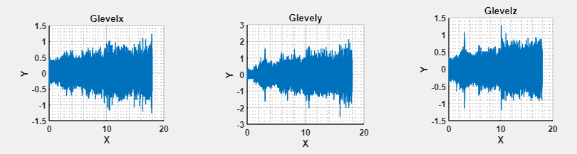

**Fig 7.4**

**G-levels for time 18-25 seconds**

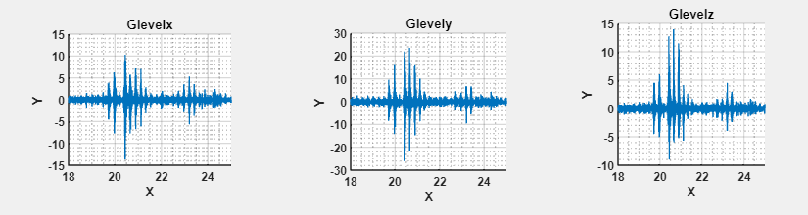

**Fig 7.6**

**7.2 PSD Graphs with their GRMS Values**

**PSD for 0-40 seconds**

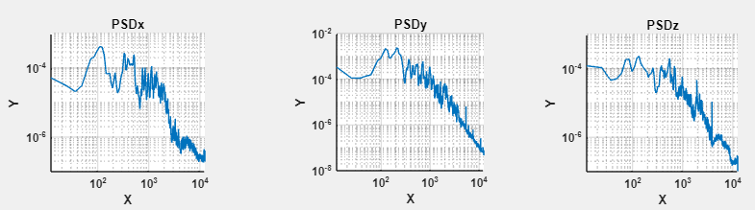

**Fig 7.7**

**GRMS for 0-40 seconds**

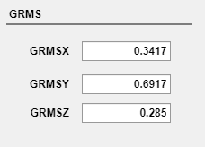

**Fig 7.8**

**PSD for 0-18 seconds**

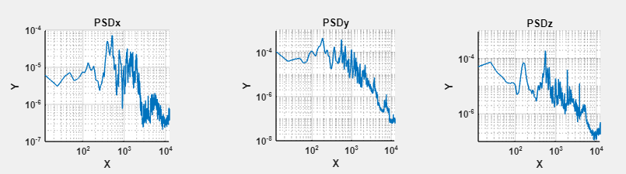

**Fig 7.9**

**GRMS for 0-18 seconds**

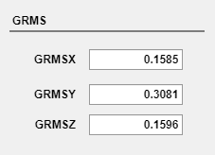

**Fig 7.10**

**PSD for 18-25 seconds**

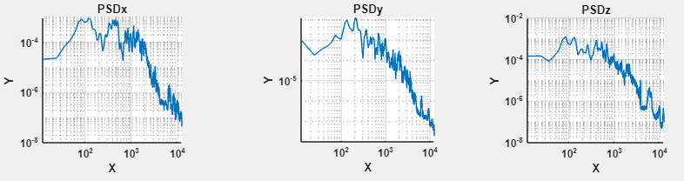

**Fig 7.11**

**GRMS for 18-25 seconds**



G-force (or gravitational force equivalent) experienced during different activities varies significantly. Here are some typical values for everyday activities:

1. **Walking**: Around 1.1 to 1.2 g
2. **Running**: Generally around 1.5 to 2 g, depending on speed and stride.
3. **Jumping**: Landing can generate up to 3 to 5 g, depending on height and technique.
4. **Sneezing**: Can generate up to 2.9 g momentarily.

These values are approximate and can vary based on individual differences and specific circumstances of the activity.

4o

give for some more activities

ChatGPT

Certainly! Here are g-force levels for a wider range of activities:

1. **Sitting Down**: Around 1 g (baseline gravity experienced while stationary).
2. **Standing Up Quickly**: Approximately 1.3 to 1.5 g.
3. **Climbing Stairs**: Around 1.5 to 2 g.
4. **Riding a Bicycle**:
   * At moderate speeds: About 1.2 to 1.5 g.
   * Over bumps or rough terrain: Can spike up to 2 to 3 g.
5. **Driving a Car**:
   * Normal driving: Around 1 to 1.3 g.
   * Hard braking or acceleration: Up to 1.5 to 2 g.
   * Sharp turns: Up to 2 to 3 g.
6. **Roller Coasters**:
   * Mild roller coasters: 2 to 3 g.
   * Extreme roller coasters: Up to 4 to 6 g.
7. **Skydiving (Free Fall)**: Approximately 1 g, similar to the sensation of weightlessness (not truly zero-g).
8. **Punching a Bag**: Momentary peaks can reach up to 2 to 4 g depending on the force of the punch.
9. **Coughing**: Can generate momentary forces up to 3.5 g.
10. **Driving Off-Road**: Depending on the terrain, can experience forces up to 4 to 5 g.